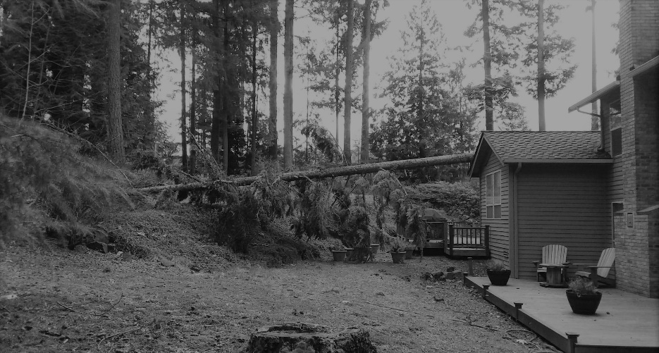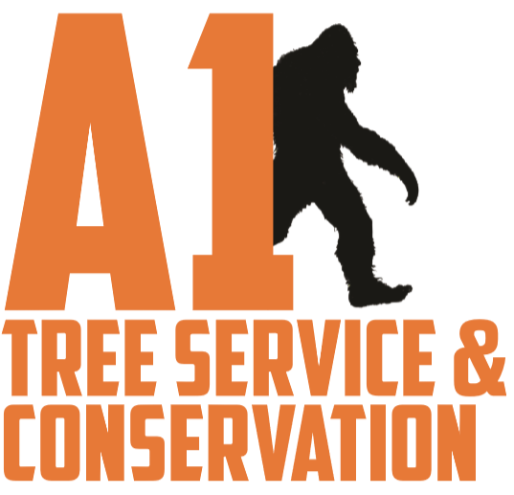

**SERVICES**

Emergencies

Thinning

Topping

Stump Grinding

Skirting

Tree Removal

Hedging

Pruning

Windsailing

MENTION THIS FLYER AND GET **10%** OFF WHEN YOU SCHEDULE BEFORE MARCH 1, 2019

**ARE YOU READY FOR THE NEXT WIND STORM?**

**CALL OR TEXT DREW TODAY FOR A**

**FREE QUOTE 425-883-3446**

UNDER NEW OWNERSHIP

SAME RELIABLE CREW